PORMULARYO PARA SA IMPORMASIYON NG ARI-ARIANG KULTURAL NA DI-NATITINAG
PRECUP Form for Immovable Cultural Property

NUMERO NG REHISTRO (Ito ay pupunanlamang ng kawani ng PRECUP)
PRECUP Form 1
Registry Number (To be filled by PRECUP staff only)
BANSA (Country)  PHILIPPINES | LUGAR (Area) | IDENTIFIER | PROPERTY NUMBER

KAILANGANG PUNAN (Required Field)
1* | PANGALAN NG ARI-ARIANG KULTURAL (Name of Cultural Property)
OPISYAL NA PANGALAN (Official Name):
SAINT JAMES THE APOSTLE PARISH
KARANIWANG PANGALAN (Common Name):
SAINT JAMES THE APOSTLE PARISH
LOKAL NA PANGALAN (Local name):
SAINT JAMES THE APOSTLE PARISH

KAILANGANG PUNAN (Required Field)
2* | LOKASYON (Location)
MAHALAGANG PAALALA: Ang datos ng Street Address at Barangay ng ari-ariangkultural ay mananatilingkompidensyal at hindimaaaringisapublikohangga’thindiitoipinapaalamsa may-ari, kung ang pag-aari ay hindinakikita o napupuntahan ng publiko.
IMPORTANT NOTICE: The information on Street Address and Barangay provided shall remain confidential and shall not be posted publicly unless permission has been obtained from the owner, if the property is inaccessible to the public.
NUMERO AT ADRES (Street Address):
SANTIAGO ST.
BARANGAY [KASAMA ANG BARYO, SITIO, O PUROK KUNG MAYROON]:
Barangay (with barrio, sitio, or purok when applicable)
POBLACION
LUNGSOD/BAYAN (City/Municipality)  CATEEL |  |  | LALAWIGAN (Province)  DAVAO ORIENTAL | REHIYON (Region)  REGION 11
HEOGRAPIKAL NA KOORDINEYTS  (Geographical Coordinates)  MaaaringHINDIpunan ang impormasiyonghinihingidito.  (These data fields areNOT REQUIRED) |  | LONGITUD (Longitude):
 |  | LATITUD (Latitude):

3a | KLASIPIKASYON / PAG-UURI (Classification)  PANUTO: itsek ang angkopnasagot  INSTRUCTION: Place a check on the appropriate answer
KATEGORYA  (Category) |  | PAGMAMAY-ARI  (Ownership) |  |  |  | KALAGAYAN  (Status) |  |  |  | NAPUPUNTAHAN NG PUBLIKO  (Public Accessibility)
 | ISTRUKTURA  (Structure) |  | PRIBADO (Private) |  |  |  | OKUPADO  (Occupied) |  |  | OO [ ]  (Yes)  HINDI [ ]  (No)
 |  |  | PUBLIKO (Public)
 |  |  | PAREHO (Both) |  |  |  | DI OKUPADO  (Not Occupied)
 | POOK PANGKALIKASAN  (Natural Sites) | PAGKAMIT  (Public Acquisition)
 | MAKASAYSAYAN / KULTURAL NA POOK  (Cultural Landscape / Site) |  | PINOPROSESO  (In Progress) |  |  |  | KASALUKUYANG MAY GAWAIN NG PANGANGALAGA  (Preservation work in Progress)
IBA (Others) |  |  | ISINASAALANG-ALANG  (Being Considered)
WALANG PLANONG KUNIN
(No Plans of Acquisition)
KASALUKUYANG GAMIT SA LUPA (Current Land Use)
PANUTO: Maaaringbasahin ang manual para punan ang angkopnasagot para sakasalukuyanggamit ng ari-ariangkultural.
NOTE: Please read the manual for current land use for cultural property.
 | PANGTIRAHAN  (Residential) |  |  |  | TRANSPORTASYON, MGA UTILIDAD, AT SERBISYO  (Transportation, Utilities, and Services) |  |  |  | MGA POOK  (Sites)
 | PANGKOMERSYO  (Commercial) |  |  |  | LIWASAN AT PANLIBANGAN  (Parks and Recreation) |  |  |  | PANGMILITAR  (Military)
 | PANG-INDUSTRIYA  (Industrial) |  |  |  | LIBINGAN  (Cemetery) |  |  |  | PANG-AGRIKULTURA  (Agricultural)
 | PANG-INSTITUSYON  (Institutional) |  |  |  | MGA BANTAYOG AT DAMBANA  (Monuments and Shrines) |  |  |  | IBA’T-IBANG GAMIT, TUKUYIN  (Mixed Use, Please Identify):
3b | KLASIPIKASYON / PAG-UURI (Classification)  PANUTO: Itsek ang angkopnasagot  INSTRUCTION: Place a check on the appropriate answer
URI NG ARI-ARIANG KULTURAL
(Type of Cultural Property)
 | TIRAHAN  (Residential) |  | KOMPLEKS PAMPALAKASAN  (Sports Complex) | IBA PA, TUKUYIN  (Others, Please Identify)
 | GUSALING PANGKOMERSIYO  (Commercial Building) |  | BANTAYOG  (Monument)
 | GUSALING PANG-INDUSTRIYA  (Industrial Building) |  | DAMBANA  (Shrine)
 | GUSALING PAMPAMAHALAAN  (Government Building) |  | PALIPARAN  (Airport)
 | PRESINTO NG PULIS/ KAMPO NG PULIS  (Police Precinct / Police Camp) |  | DAUNGAN  (Port)
 | HIMPILAN NG PAMATAY-SUNOG  (Fire Station) |  | DAAN  (Road)
 | GUSALING PANG-EDUKASYON  (Educational Building / Academic) |  | TULAY  (Bridge)
 | AKLATAN  (Library) |  | PAROLA  (Lighthouse) | IBA’T-IBANG GAMIT, TUKUYIN:  (Mixed Use, Please Identify)
 | MUSEO  (Museum) |  | SISTEMANG DAANG-BAKAL  (Railroad System)
 | GUSALING MEDIKAL  (Medical Building) |  | PLANTA NG ENERHIYA  (Power Plant)
 | GUSALING PANRELIHIYON:  SIMBAHAN, MOSKE, TEMPLO, ATBP.  (Religious: Church, Mosque, Temple, etc.) |  | PRINSA AT/O DIKE  (Dams and/or Dikes)
 | MGA KUTA AT BANTAYAN  (Forts and Watchtowers) |  | SISTEMANG PATUBIG  (Water Works)
PASUGUAN
(Embassy)

LIWASAN
(Parks or Plaza)

KAILANGANG PUNAN (Required Field)
4* | PAGMAMAY-ARI (Ownership)
MAHALAGANG PAALALA: Ang impormasiyongito ay mananatilingkompidensyal at hindimaaaringisapublikohangga’thindiitoipinapaalamsa may-ari.
IMPORTANT NOTICE: The information provided shall remain confidential and shall not be posted publicly unless permission has been obtained from the owner.
MAY-ARI / TAGAPANGASIWA (Owner / Administrator):

NUMERO, ADRES, BARANGAY O DISTRITO (Street Address):

LUNGSOD / BAYAN (City/Municipality) |  | LALAWIGAN (Province)

5 | LOKASYON NG LEGAL NA PAGLALARAWAN (Location of Legal Description)
MAHALAGANG PAALALA: Ang impormasiyongito ay mananatilingkompidensyal at hindimaaaringisapublikohangga’thindiitoipinapaalamsa may-ari.
IMPORTANT NOTICE: The information provided shall remain confidential and shall not be posted publicly unless permission has been obtained from the owner.
NUMERO NG TITULO (Registry of Deeds):

NUMERO, ADRES, BARANGAY O DISTRITO (Street Address):

LUNGSOD / BAYAN (City/Municipality) |  | LALAWIGAN (Province)
TINATAYANG SUKAT NG ARI-ARIAN SA METRO KWADRADO (Approximate area of property in square meters)

6 | PAGLALARAWAN (Description)
KONDISYON  (Condition) |  |  | INTEGRIDAD  (Integrity)
 |  | MAHUSAY NA KONDISYON  (Excellent) |  | MAYROONG NABAGO O NAIBA  (Altered)
 |  | MABUTING KONDISYON  (Good) |  | WALANG NABAGO O NAIBA  (Unaltered)
 |  | KATAMTAMANG AYOS NA KONDISYON  (Fair) |  | INILIPAT  (Moved)
 |  | NASISIRANG KONDISYON  (Deteriorated) |  | ORIHINAL NA LUGAR  (Original Site)
 |  | SIRA / GUHO  (Ruins) | ANG BAHAGING ITO AY MAAARING MANGANGAILANGAN NG TEKNIKAL NA KAALAMAN. SUMANGGUNI SA PRECUP FORM MANUAL, MGA LOKAL NA EKSPERTO, O SA MGA AHENSIYANG KULTURAL.  (This section may need technical knowledge. You may refer to the PRECUP Form manual, with local experts, or cultural agencies.)
DI NAKIKITA
(Unexposed)

PAKILARAWAN ANG KASALUKUYAN AT ORIHINAL NA ANYONG PISIKAL (KUNG MAYROON).
MAAARING GUMAMIT NG HIWALAY NA PAHINA PARA SA KARAGDAGANG IMPORMASYON.
Describe the present and original (if available) physical appearance. You may use a separate sheet for more information.
The church is painted in beige with details of apricot colour; its roof is coloured blue.
Inside the church lies the statue of the patron saint on the left side of the pulpit, riding in his horse while carrying his sword.
Century-old tree trunks serves as pillars of the church, each is hanged with a cement tablet depicting the mysteries of the Holy Rosary.
At the centre of the pulpit is a statue of Jesus on the Cross. Each side has a portrait of the Virgin Mary and the Holy Child.

PAKILARAWAN ANG MGA NAGDAANG PAGBABAGO O INTERBENSIYON.
MAAARING GUMAMIT NG HIWALAY NA PAHINA PARA SA KARAGDAGANG IMPORMASYON.
Describe the previous changes or interventions. You may use a separate sheet for more information.
The building’s colour is occasionally changed for the purpose of cleanliness.

7a | MGA POTENSIYAL NA PANGANIB (Potential Threats)
 | LINDOL  (Earthquake) |  |  | DALUYONG  (Storm Surge)
 | PAGPUTOK NG BULKAN AT MGA KAUGNAY NA PANGYAYARI TULAD NG PAGDALOY NG LAHAR O LAVA  (Volcanic Eruption and its associated phenomenon like lahar or lava flows) |  |  | PAGTAAS NG TUBIG DAGAT DAHIL SA PAGBABAGONG KLIMA  (Sea level rise due to climate change)
 | PAGGUHO NG LUPA  (Land or mudslides) |  |  | SUNOG  (Fire)
 | TSUNAMI O MALAKING ALON DALA NG PAGLINDOL  (Tsunami) |  |  | TAGTUYOT  (Drought)
 | BAGYO, BUHAWI, O MALAKAS NA HANGIN  (Typhoons, Tornadoes, or Strong Wind) |  |  | NAPABAYAAN, KASAMA ANG PLANONG PAGPAPAGIBA  (Negligence, including plans of demolition)
 | MALAKAS NA PAG-ULAN, O HABAGAT, AT MGA KAUGNAY NA PANGYAYARI TULAD NG PAGBAHA  (Strong Rain or Monsoon Rains, and associated phenomenon like flooding) |  |  | DIGMAAN O ARMADONG PAKIKIBAKA  (War or Armed Conflict)
 | PAGBAHA  (Floods or Flash Floods) |  |  | IBA PA, TUKUYIN  (Others, please specify)
7b | PANGKALAHATANG ANTAS NG PANGANIB  (General Threat Level)
 | PULANG ALERT  Red Alert | Ang nasabing alertay nagbabadya ng malakingpanganibsaari-ariangkultural at nangangailangan ng madalian oagadnaaksyonmulasakinauukulan.  This level indicates direct and severe threat to the cultural property. IMMEDIATE ACTION is needed.
 | BUGHAW NA ALERT  Blue Alert | Ang nasabing alert ay nagpapabatid ng panganibsaari-ariangkultural at ito’ynangangailangan ng kinauukulangaksyon.  This level indicates imminent threat to the cultural property and appropriate action is needed.
 | PUTING ALERT  White Alert | Ang nasabingantas ay nagpapabatidna ang ari-ariangkultural ay malayosatiyaknakapahamakan. Subalitito ay hindigumagarantiyanahindiitomapapahamaksadaratingnapanahon. Maaaringkaukulangpaghahanda ang kinakailangan para maprotektahan ang nasabingari-ariangkultural.  This level indicates no immediate threat to the cultural property. However, it does not guarantee that it will be risk free in the near future. Preparatory action may be needed to protect the property from threat.
7c | PAHAYAG NG POTENSYAL NA PANGANIB AT BATAYAN  (Statement of Potential Threat and its Reference)
MAAARING ILAGAY ANG DAGDAG NA IMPORMASYON, IBANG MGA LARAWAN AT GUHIT SA HIWALAY NA MGA PAHINA
(Attach additional information, other photographs, and sketches in separate sheets)

Saint James the Apostle Parish is facing the Pacific Ocean. If tsunamis occur, the church is the first to get hit.

7d | MGA SINUONG NA PANGANIB  (Previous threats that were encountered)
ILAKIP ANG DAGDAG NA IMPORMASYON, IBANG MGA LARAWAN AT GUHIT SA HIWALAY NA MGA PAHINA
(Attach additional information, other photographs, and sketches in separate sheets)

The edifice of the church when Jesuit Fathers arrived was first built in 1862. Later it was destroyed by an earthquake. The second edifice church was built in 1883 under Father Zambo. The present church, which was built in 1900 when Father Peroga arrived, was destroyed by a typhoon. It was then rebuilt in 1918 and remodelled in 1953.
Last December of the year 2012, the Typhoon Pablo struck Cateel and its neighbouring municipalities, leaving a devastating effect to Cateel. However, the church only sustained roof damage. Its original structure was intact.

8 | PLANO NG LOKASYON / MAPA (Location Plan)
ILAKIP ANG IBANG MGA LARAWAN AT GUHIT SA HIWALAY NA MGA PAHINA
(Attach other photographs and sketches in separate sheets)

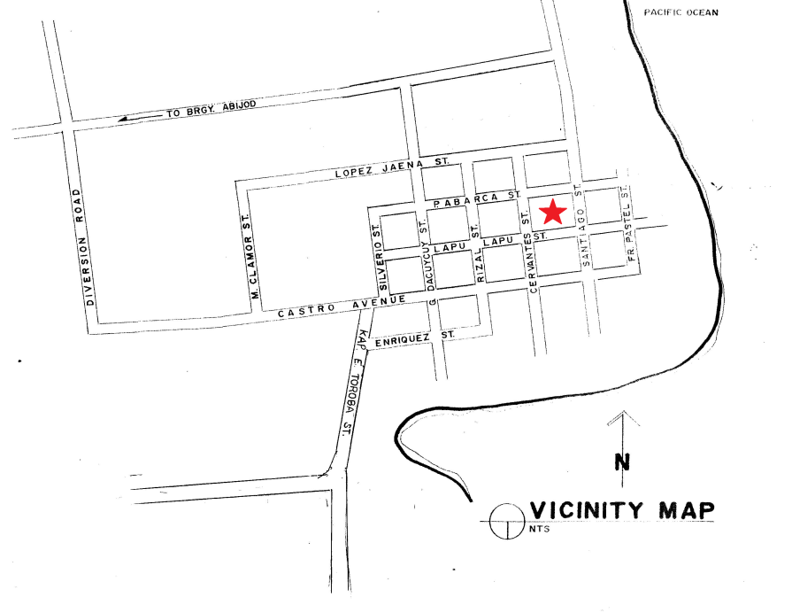

BARANGAY POBLACION MAP

KAILANGANG PUNAN (Required Field)
9a* | KABULUHAN (Significance)  PAALALA: Ipahiwatig ang angkopnasagotsapamamagitan ng paglagay ng tseksa box sakaliwa ng kolum ng “pangunahingkatangian” at ipaliwanagitosakolum ng “pahayag ng kabuluhan.”  (Note: Indicate the appropriate answer by ticking the box on the left portion of the “Primary Criteria” column and explain it on the “Statement of Significance” column.)
PANGUNAHING KATANGIAN  (Primary Criteria) |  | PAHAYAG NG KABULUHAN  (Statement of Significance)
 | MAKASAYSAYANG KABULUHAN(Historical Significance) | The Church is built by a Spanish Jesuit Missionary in 1894, it was remodeled by a Canadian PME Missionary in 1952 and renovated by a Filipino Diocesan clergy in 1994 on its centenary celebration of Christianity.
PANLIPUNAN O ESPIRITWAL NA KABULUHAN
(Social or Spiritual Significance)
PULITIKAL NA KABULUHAN
(Social or Spiritual Significance)
PANGEKONOMIYANG KABULUHAN
(EconomicSignificance)

PANG-AGHAM, PANANALIKSIK, O TEKNOLOHIKAL NA KABULUHAN
(Scientific, Research, or Technological Significance)

PANSINING NA KABULUHAN
(Aesthetic or Artistic Significance)

9b* | KABULUHAN (Significance)  PAALALA: Ipahiwatig ang angkopnasagotsapamamagitan ng paglagay ng tseksa box sakaliwa ng kolum ng “pahambingnakatangian” at ipaliwanagitosakolum ng “pahayag ng kabuluhan.”  (Note: Indicate the appropriate answer by ticking the box on the left portion of the “Primary Criteria” column and explain it on the “Statement of Significance” column.)
PAHAMBING NA KATANGIAN  (Primary Criteria) |  | PAHAYAG NG KABULUHAN  (Statement of Significance)
PINANGGALINGAN
(Provenance)
 | PAGKAKATAWAN  (Representativeness) | The Saint James the Apostle Church is the living symbol of the Roman Catholic faith in the Municipality of Cateel.
PAGKABIHIRA
(Rarity)
MAPAGPALIWANAG NA POTENSIYAL
(Interpretative Potential)

9c* |  | KABULUHAN (Significance)
KAPANAHUNAN
(Period)
 |  | BAGO SAKUPIN, BAGO ANG TAONG 1560  (Pre-Colonial Period, before 1560) |  |  |  |  | HINDI MATUKOY  (Unidentified)
PANAHON NG ESPANYOL, 1560 - 1898
(Spanish Colonial Period, 1560 – 1898)

PANAHON NG AMERIKANO, 1899-1941
(American Colonial Period, 1899-1941)

PANAHON NG IKALAWANG DIGMAANG PANDAIGDIG, 1941-1945
(World War II)

PANAHON PAGKARAAN NG IKALAWANG DIGMAANG PANDAIGDIG,
1945 – 1986
(Post War Period, 1945-1986)

TIYAK NA PETSA (Specific Date)
MGA BAHAGI NG KABULUHAN
(Areas of Significance)
 | ANTROPOLIHIYA  (Anthropology) |  |  | LIBANGAN  (Entertainment) |  | MUSIKA  (Music) |  |  | ISKULTURA  (Sculpture)
 | PANG-ARKEOLOHIYA  (Archaeological) |  |  | HERITAGE SITE  (PookPamana) |  | PAGPINTA  (Painting) |  |  | PANLIPUNAN / HUMANITARYAN  (Social / Humanitarian)
 | ARKITEKTURA  (Architecture) |  |  | INDUSTRIYA  (Industrial) |  | PILOSOPIYA  (Philosophy) |  |  | TRANSPORTASYON  (Transportation)
 | KOMERSIYO  (Commercial) |  |  | TANAWIN  (Landscape) |  | POLITIKAL  (Political) |  |  | PAGPAPLANO NG LUNGSOD  (Urban Planning)
 | KOMUNIKASYON  (Communication) |  |  | PANITIKAN  (Literature) |  | RELIHIYON  (Religion) |  |  | IBA PA, TUKUYIN:  (Others, please specify)
 | EDUKASYON  (Education) |  |  | MILITAR  (Military) |  | AGHAM  (Science)

10 | MGA KUWENTO O PAMANANG HIGIT SA NASASALAT NA MAY KAUGNAYAN SA ARI-ARIANG KULTURAL  (Stories or Intangible Heritage Associated with the Cultural Property)
MAAARING ILAGAY ANG DAGDAG NA IMPORMASYON, IBANG MGA LARAWAN AT GUHIT SA HIWALAY NA MGA PAHINA
(Attach additional information, other photographs, and sketches in separate sheets)

The people of Cateel celebrated the centenary of the parish of Cateel on July 25, 1994 on the basis of a royal decree erecting the Cateel-Baganga on May 1, 1894. The foundation year of Saint James the Apostle took place in 1894 attested by the oldest Libro de Bautismo of the parish dated June 1894.
It was pointed out that the Jesuits’ favourite patron saint is Sant James while the Recollects is Saint Nicolas. From early part of the 1600’s until 1876, the Recollects took charge in the Evangelization of Eastern Mindanao that includes Cateel. The visita de Cateel was abandoned by the Recollects due to lack of manpower.
According to Salvador Pacis in his book, Davao History and Progress, the edifice of the church when Jesuit Fathers arrived was first built in 1862. Later it was destroyed by an earthquake. The second edifice church was built in 1883 under Father Zambo. The present church, which was built in 1900 when Father Peroga arrived, was destroyed by a typhoon. It was then rebuilt in 1918 and remodelled in 1953. There is no available record on file what was the patron saint of the Roman Catholic Church in Cateel during those times.

11 | MGA PANGUNAHING SANGGUNIAN (Major Bibliographic References and Key Informants)
MAAARING ILAGAY ANG DAGDAG NA IMPORMASYON, IBANG MGA LARAWAN AT GUHIT SA HIWALAY NA MGA PAHINA
(Attach additional information, other photographs, and sketches in separate sheets)

PAGE 27 AND 62, CATEEL CENTENNIAL BOOK 2003

12 | DEKLARASYON (Declaration)
Pambansa/PandaigdigangDeklarasyon
(National/International-level Declaration)
 | POOK NA PAMANANG PANDAIGDIG  (UNESCO World Heritage Site) |  | PAMBANSANG PALATANDAANG/ POOK PANGKASAYSAYAN  (National Historical Landmark / Site)
 | PAMBANSANG YAMANG PANGKALINANGAN  (National Cultural Treasure) |  | PAMBANSANG DAMBANA  (National Shrine)
 | MAHALAGANG ARI-ARIANG PANGKALINANGAN  (Important Cultural Property) |  | PAMBANSANG BANTAYOG  (National Monument)
 | ARI-ARIANG PANGKALINANGAN  (Cultural Property) |  | PANANDANG PANGKASAYSAYAN  (Historical Marker)
 | LUGAR NG PAMANA  (HeritageZone) |  | WALANG DEKLARASYON O ITINUTURING NA ARI-ARIANG KULTURAL  (No declaration or Presumed Cultural Property)
 | PAMANANG BAHAY  (Heritage House) |  | IBA PA, TUKUYIN  (Others, please specify below)
LokalnaDeklarasyon
(Local Declaration)
 | PANREHIYON  (Regional) |  | PANLALAWIGAN  (Provincial)
 | PANGLUNGSOD O PAMBAYAN  (City or Municipal) |  | PAMBARANGAY O DISTRITO  (Barangay or District)
 | WALANG DEKLARASYON O ITINUTURING NA ARI-ARIANG KULTURAL  (No declaration or Presumed Cultural Property) |  | IBA PA, TUKUYIN  (Others, please specify below)

KAILANGANG PUNAN (Required Field)
13 | LARAWAN NG ARI-ARIANG KULTURAL(Photograph of the Cultural Property)
ILAKIP ANG IBANG MGA LARAWAN AT GUHIT SA HIWALAY NA MGA PAHINA KUNG KINAKAILANGAN
(Attach other photographs and sketches in separate sheets, if possible)

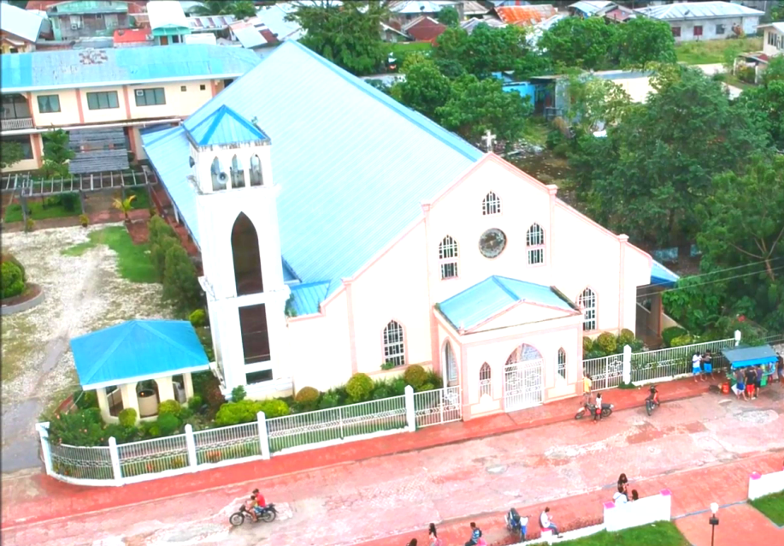
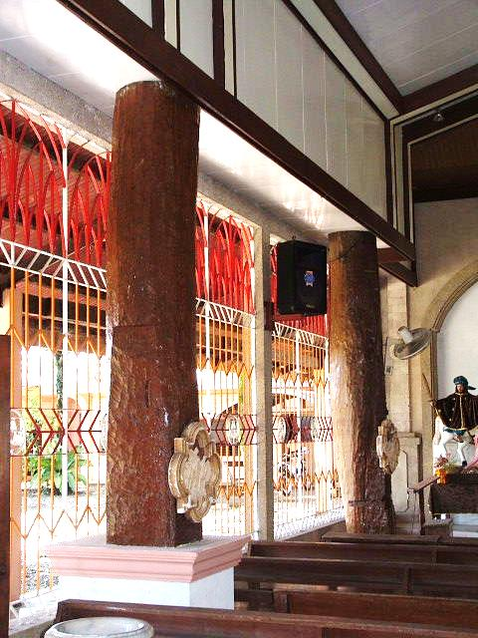

14 | INIHANDA NI / NINA (Prepared By)
LAGDA (Signature):

PANGALAN (Name): LOVE JOY T. SERRA

KATUNGKULAN (Designation): ADMINISTRATIVE OFFICER II

PETSA (Date): APRIL 30, 2019

ORGANISASYON (Organization):

LGU-CATEEL
ADRES (Address):

SANTIAGO ST., POBLACION, CATEEL, DAVAO ORIENTAL

